**Preparation of Poster**

Each presenter is provided with a 700 mm wide x 1000 mm high poster board. Two posters will be displayed on each side of a single board (two or four posters per board dependent on poster board). The poster must not exceed the size limit. Please prepare your poster as shown below :

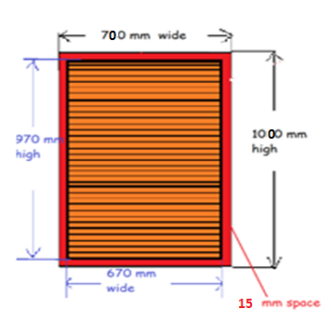

* The presentation must cover the material as cited in the abstract.
* Place the title of your paper prominently at the top of the poster to allow viewers to identify your paper.
* Highlight the authors’ names and contact information in case the viewer is interested in more information.
* Prepare diagrams or charts legibly in a size sufficient to be read at a distance of 2 meters.
* Paragraph and figure captions should be at least in a 24-point font (10 mm height) and headers at least in a 36-point font (12 mm height). Be creative by using different font sizes and styles.
* When working with graphs or charts, use different colors and textures/symbols for each line or bar.
* The presentation time is about 100 min